# Grove - XBee Carrier

|  |
| --- |
| Contents  [[hide](javascript:toggleToc())]   * [1 Introduction](http://www.seeedstudio.com/wiki/Grove_-_XBee_Carrier#Introduction) * [2 Features](http://www.seeedstudio.com/wiki/Grove_-_XBee_Carrier#Features) * [3 Application Ideas](http://www.seeedstudio.com/wiki/Grove_-_XBee_Carrier#Application_Ideas) * [4 Cautions](http://www.seeedstudio.com/wiki/Grove_-_XBee_Carrier#Cautions) * [5 Schematic](http://www.seeedstudio.com/wiki/Grove_-_XBee_Carrier#Schematic) * [6 Specification](http://www.seeedstudio.com/wiki/Grove_-_XBee_Carrier#Specification)   + [6.1 Key Specification](http://www.seeedstudio.com/wiki/Grove_-_XBee_Carrier#Key_Specification) * [7 Hardware & Pin definition](http://www.seeedstudio.com/wiki/Grove_-_XBee_Carrier#Hardware_.26_Pin_definition) * [8 Mechanical Dimensions](http://www.seeedstudio.com/wiki/Grove_-_XBee_Carrier#Mechanical_Dimensions) * [9 Usage](http://www.seeedstudio.com/wiki/Grove_-_XBee_Carrier#Usage)   + [9.1 Hardware Installation](http://www.seeedstudio.com/wiki/Grove_-_XBee_Carrier#Hardware_Installation)     - [9.1.1 Charging](http://www.seeedstudio.com/wiki/Grove_-_XBee_Carrier#Charging)     - [9.1.2 Working with Standalone Bee Nodes](http://www.seeedstudio.com/wiki/Grove_-_XBee_Carrier#Working_with_Standalone_Bee_Nodes)     - [9.1.3 Working with Bee Modules](http://www.seeedstudio.com/wiki/Grove_-_XBee_Carrier#Working_with_Bee_Modules)   + [9.2 Programming](http://www.seeedstudio.com/wiki/Grove_-_XBee_Carrier#Programming) * [10 Bill of Materials (BOM) /parts list](http://www.seeedstudio.com/wiki/Grove_-_XBee_Carrier#Bill_of_Materials_.28BOM.29_.2Fparts_list) * [11 FAQ](http://www.seeedstudio.com/wiki/Grove_-_XBee_Carrier#FAQ) * [12 Support](http://www.seeedstudio.com/wiki/Grove_-_XBee_Carrier#Support) * [13 Version Tracker](http://www.seeedstudio.com/wiki/Grove_-_XBee_Carrier#Version_Tracker) * [14 Bug Tracker](http://www.seeedstudio.com/wiki/Grove_-_XBee_Carrier#Bug_Tracker) * [15 Additional Idea](http://www.seeedstudio.com/wiki/Grove_-_XBee_Carrier#Additional_Idea) * [16 Resources](http://www.seeedstudio.com/wiki/Grove_-_XBee_Carrier#Resources) * [17 How to buy](http://www.seeedstudio.com/wiki/Grove_-_XBee_Carrier#How_to_buy) * [18 See Also](http://www.seeedstudio.com/wiki/Grove_-_XBee_Carrier#See_Also) * [19 Licensing](http://www.seeedstudio.com/wiki/Grove_-_XBee_Carrier#Licensing) * [20 External Links](http://www.seeedstudio.com/wiki/Grove_-_XBee_Carrier#External_Links) |

## Introduction

**Grove - XBee Carrier** is a **Wireless Sensor Network** (WSN) base board designed for Bee series and Grove units. It is primarily suitable for standalone Bee Nodes like [RFBee](http://www.seeedstudio.com/wiki/RFbee_V1.1_-_Wireless_Arduino_compatible_node), [Wifi Bee](http://www.seeedstudio.com/wiki/Wifi_Bee) which have **ATMega328**onboard and **XBee** (Zigbee) modules. It is compatible with [RFBee](http://www.seeedstudio.com/wiki/RFbee_V1.1_-_Wireless_Arduino_compatible_node), [Wifi Bee](http://www.seeedstudio.com/wiki/Wifi_Bee) , [XBee](http://garden.seeedstudio.com/index.php?title=Bee_series#ZigBee) and [Bluetooth Bee](http://www.seeedstudio.com/wiki/Bluetooth_Bee). Besides a Bee receptacle, there are also two Grove connectors. The board cab be powered by a [lithium battery](http://garden.seeedstudio.com/index.php?title=Batteries_and_Chargers#Lithium-ion_Polymer_Battery_Packs) or through USB cable. You can use a Wireless charger, [Solar Panel](http://garden.seeedstudio.com/index.php?title=Batteries_and_Chargers#Solar_Power) or the USB cable to charge the battery. The **FT232RL** chip onboard helps in downloading the program to Bee Module directly.

Bees which do not have **ATMega328** like [Bluetooth Bee](http://www.seeedstudio.com/wiki/Bluetooth_Bee) can only be configured by using on-board **FT232RL**(USB to UART). Theses Bees are not suitable for standalone applications.

The on-board **FT232RL** can be used like any other **3.3V USB to UART** interface when not connected to any Bee Modules. This is useful for programming a 3.3V MCU through Serial Port.

**Model:**[**SLD71385P**](http://www.seeedstudio.com/depot/grove-xbee-carrier-p-905.html?cPath=132_134)

[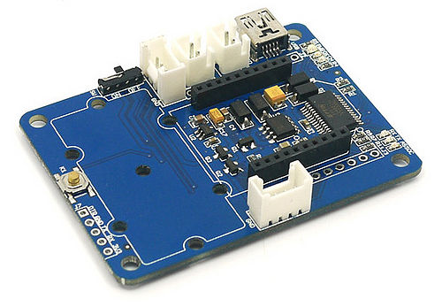](http://www.seeedstudio.com/wiki/File:Bee_Stem.jpg)

[http://www.seeedstudio.com/wiki/skins/common/images/magnify-clip.png](http://www.seeedstudio.com/wiki/File:Bee_Stem.jpg)

Grove - XBee Carrier

## Features

* Bees Compatible Receptacle
* Two Grove Connector - One for I2C and other for D6,D5
* Two Grove Place Holders
* On-Board Charge Controller [CN3063](http://www.consonance-elec.com/pdf/%E6%8A%80%E6%9C%AF%E8%AF%B4%E6%98%8E%E4%B9%A6/DSE-CN3063.pdf)
* On-Board 3.3V LDO Lownoise Micropower Regulator - [RT9167A_33PB](http://www.richtek.com/download_ds.jsp?s=238)
* On-board FT232RL UBS-UART IC
* LEDs for PWR, Charge Indication and UART transmission.
* Power Switch
* Reset Button

## Application Ideas

* Wireless Sensor Network with Standalone Bee Node like [Wifi Bee](http://www.seeedstudio.com/wiki/Wifi_Bee).
* As a configuration aid for Bees using FT232RL.
* Charger for Lithium Ion Cells using on-board charge controller.
* As a FT232RL based 3.3v USB-UART.

## Cautions

* Insert the Bees in the proper direction. Use the Bee outline on the silk-screen.

## Schematic

[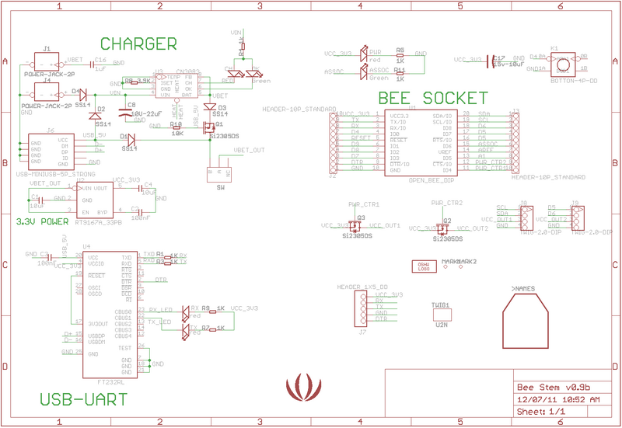](http://www.seeedstudio.com/wiki/File:Bee_Stem_v0.9b_schematic.png)

## Specification

### Key Specification

|  |  |  |  |
| --- | --- | --- | --- |
| **Item** | **Minimum** | **Typical** | **Maximum** |
| Operating Voltage | 3.0V | 3.3V | 3.6V |
| Charge Controller | **CN3063**. | | |
| CHARGER (Charging Voltage for LiPo Battery) | 4.4V to 6V (as per CN3063 Spec) | | |
| 3.3V LDO | Low Noise and Micropower type. Suitable for Battery Application. | | |
| I/O Logic | 3.3V Logic | | |

## Hardware & Pin definition

[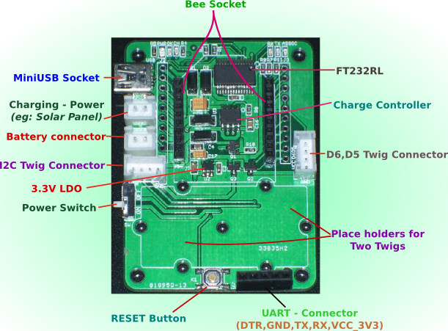](http://www.seeedstudio.com/wiki/File:Bee_Stem_Parts.png)

## Mechanical Dimensions

**Grove - XBee Carrier** is of **63.11mm x 46.86mm** size.

[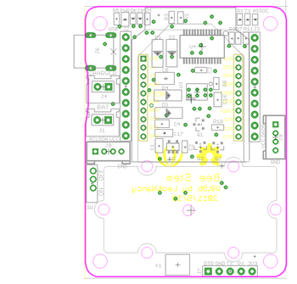](http://www.seeedstudio.com/wiki/File:Bee_Stem_v0.9b_board.png)

## Usage

When using an RFBee, the following pinouts apply for using the arduino IDE

Pin 5 is the Grove connector for I/O - Yellow wire

Pin 6 is the Grove connector for I/O - White wire

[Note: you can use the [x2 Grove cable](http://www.seeedstudio.com/depot/universal-4-pin-to-x2-4-pin-cable-5-pcs-pack-p-847.html?cPath=178_179) with the white and yellow wires swapped on one to access both I/O.

Pin 16 may need to be driven low to provide enough power to the I/O Grove [via mosfet]

Pin 17 may need to be driven low to provide enough power to the I2C Grove [via mosfet]

### Hardware Installation

#### Charging

Now you can choose a suitable battery for your application from **SeeedStudio** [Batteries and Chargers](http://www.seeedstudio.com/wiki/Batteries_and_Chargers)

1. Connect a 3.7v LiPo battery to **BAT** JST-socket.
2. Connect a power source like Solar Panel to **CHARGER** JST-Socket.
3. The Battery will be continuous charged. The end of charging would be indicated by LED marked 'OK'.

[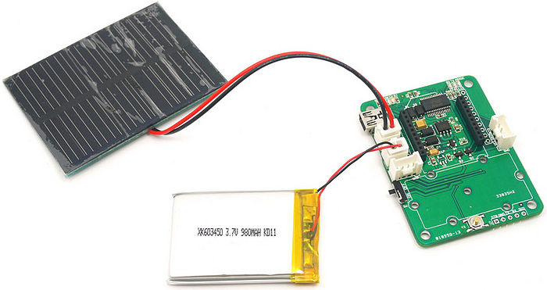](http://www.seeedstudio.com/wiki/File:Bee_Stem_with_LiPOBattery_Being_Charged_By_SolarCell.jpg)

[http://www.seeedstudio.com/wiki/skins/common/images/magnify-clip.png](http://www.seeedstudio.com/wiki/File:Bee_Stem_with_LiPOBattery_Being_Charged_By_SolarCell.jpg)

**Grove - XBee Carrier - Connected to**[**LiPo Battery**](http://garden.seeedstudio.com/index.php?title=Lithium_lon_polymer_Batteries_-_980mAh) & Charged By [**Solar Panel**](http://garden.seeedstudio.com/index.php?title=0.5w_Solar_Panel_55*70)

#### Working with Standalone Bee Nodes

Bee Nodes are standalone Arduino Compatible Wireless Nodes. **SeeedStudio** has two such Node - [Wifi Bee](http://www.seeedstudio.com/wiki/Wifi_Bee) and [RFBee](http://www.seeedstudio.com/wiki/RFbee_V1.1_-_Wireless_Arduino_compatible_node).

* The following image illustrated the connection of [WiFi Bee](http://www.seeedstudio.com/wiki/Wifi_Bee) to **Grove - XBee Carrier**.
* Any Groves can be connected to the Grove sockets provided.
* The programming of WiFi Bee's onboard **AtMega328P** is carried by connecting to PC through USB port. (FT232RL is used)

[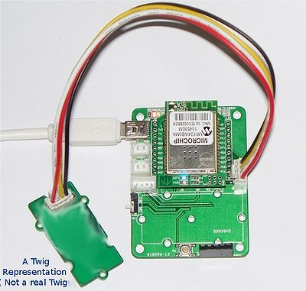](http://www.seeedstudio.com/wiki/File:Bee_Stem_Connected_to_Wifi_BEE_and_A_Twig.jpg)

[http://www.seeedstudio.com/wiki/skins/common/images/magnify-clip.png](http://www.seeedstudio.com/wiki/File:Bee_Stem_Connected_to_Wifi_BEE_and_A_Twig.jpg)

**Grove - XBee Carrier - Connected to**[**Wifi Bee**](http://www.seeedstudio.com/wiki/Wifi_Bee) and Powered By USB

* Refer [Wifi Bee usage documentation for programming examples](http://garden.seeedstudio.com/index.php?title=Wifi_Bee#Usage)

[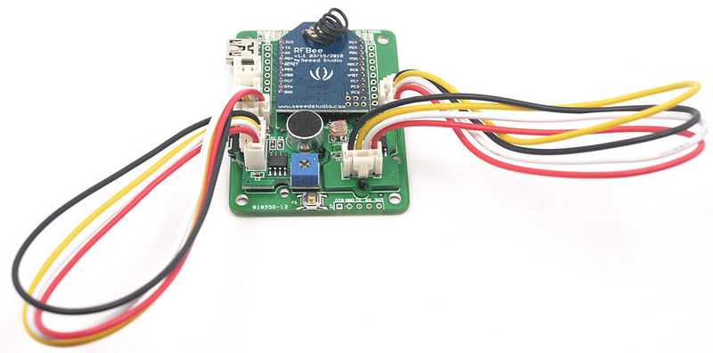](http://www.seeedstudio.com/wiki/File:Bee_Stem_Connected_To_RFBee_And_TwoTwigs.jpg)

[http://www.seeedstudio.com/wiki/skins/common/images/magnify-clip.png](http://www.seeedstudio.com/wiki/File:Bee_Stem_Connected_To_RFBee_And_TwoTwigs.jpg)

**Grove - XBee Carrier - Connected to**[**RFBee**](http://www.seeedstudio.com/wiki/RFbee_V1.1_-_Wireless_Arduino_compatible_node)**and Grove units**

#### Working with Bee Modules

This section is about those Bee modules which do not have a MCU pre-programmed with Arduino bootloader. They mostly act just like a wireless trans-receiver. These **Bee Modules** like Bluetooth Bee, etc.. can communicated with PC as well. In this case **Grove - XBee Carrier** acts like a carrier for these Bees providing necessary power, communication interface with PC through FT232RL USB to UART.

* In the below example [Bluetooth Bee](http://www.seeedstudio.com/wiki/Bluetooth_Bee) is connected to **Grove - XBee Carrier** and configured using USB-UART

[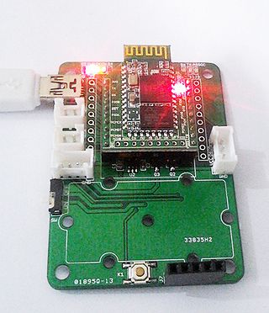](http://www.seeedstudio.com/wiki/File:Stem_XBee_Carrier_Connected_to_BluetoothBee.jpg)

[http://www.seeedstudio.com/wiki/skins/common/images/magnify-clip.png](http://www.seeedstudio.com/wiki/File:Stem_XBee_Carrier_Connected_to_BluetoothBee.jpg)

**Grove - XBee Carrier Connected to**[**Bluetooth Bee**](http://www.seeedstudio.com/wiki/Bluetooth_Bee)

* The communication of Bluetooth Bee and PC is captured with a serial port terminal application.
* You can see the commands and their reply in the screenshot below.
* The Bluetooth Bee was put into INQ mode and it even has detected a Bluetooth device in the vicinity.

[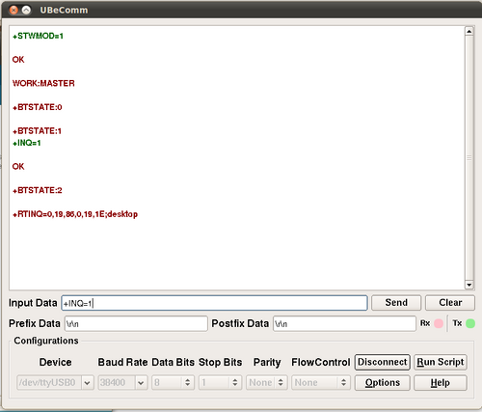](http://www.seeedstudio.com/wiki/File:Stem_XBee_Carrier_BluetoothBee_Commands.png)

* For more information on using [Bluetooth Bee](http://www.seeedstudio.com/wiki/Bluetooth_Bee), consult the [Bluetooth Bee Commands documentation](http://www.seeedstudio.com/wiki/Bluetooth_Bee#Commands_to_change_default_configuration).

### Programming

/*

Test code for use with an XBee Carrier & an RF Bee

Turns on PD5 (eg: grove relay) on for one second, then off for one second, repeatedly.

*/

void setup()

{

// initialize the digital pin as an output [Pin 5 is the Grove connector for I/O

pinMode(5, OUTPUT);

// These lines are needed to ensure that the relay will pull in [provides power to the Grove]

pinMode(16, OUTPUT);

digitalWrite(16, LOW);

}

void loop() {

digitalWrite(5, HIGH); // set the LED on

delay(1000); // wait for a second

digitalWrite(5, LOW); // set the LED off

delay(1000); // wait for a second

}

## Bill of Materials (BOM) /parts list

|  |  |  |  |
| --- | --- | --- | --- |
| **Part** | **Quantity** | **Value** | **Package** |
| ASSOC,OK | 2 | Green | D0603 |
| C1,C4 | 2 | 10uF | 0805 |
| C2,C3 | 2 | 100nF | 0603 |
| C8 | 1 | 10V-22uF | AVX-B |
| C16 | 1 | 1uF | 0805 |
| C17 | 1 | 15v-10uF | AVX-A |
| CH | 1 | RED | D0603 |
| D1,D2,D3,D4 | 4 | SS14 | D2010 |
| J1,J4 | 2 | POWER-JACK-2P | POWER-JACK-2P |
| J2,J3 | 2 | HEADER-10P_STANDARD | 2.54_10P |
| J6 | 1 | USB-MINIUSB-5P_STRONG | MINI_STRONG |
| J7 | 1 | HEADER_1X5_DD | CK_1X5 |
| J8,J9 | 2 | GROVE-2.0-DIP | 2.0_1X4 |
| K1 | 1 | BOTTON-4P-DD | BTN-S |
| PWR | 1 | red | D0805 |
| Q1,Q2,Q3 | 3 | Si2305DS | SOT23 |
| R1-R,R5-R,R9,R9 | 6 | 1K | 0603 |
| R4 | 1 | 1k | 0603 |
| R8 | 1 | 3.9K | 0603 |
| R10 | 1 | 10K | 0603 |
| RX,TX | 2 | red | D0603 |
| SW | 1 |  | 008-SW-3P-DIP |
| U1 | 1 | OPEN_BEE_DIP | CCBEE-PRO |
| U2 | 1 | RT9167A_33PB | SOT23-5 |
| U3 | 1 | CN3083 or CN3063 | SOP8 |
| U4 | 1 | FT232RL | SSOP28 |

## FAQ

Is the charger on the XBee Carrier OK to use with LiPo cells with no built in overcharge/over-discharge circuitry?

Please list your question here:

## Support

If you have questions or other better design ideas, you can go to our [forum](http://www.seeedstudio.com/forum) or [wish](http://wish.seeedstudio.com/) to discuss.

## Version Tracker

|  |  |  |
| --- | --- | --- |
| **Revision** | **Descriptions** | **Release** |
| v0.9b | Initial public release | 13th July 2011 |

## Bug Tracker

Bug Tracker is the place you can publish any bugs you think you might have found during use. Please write down what you have to say, your answers will help us improve our products.

v 0.9b : So called "Reset Button" is connected to PD4 and not to RESET --[Xelophon](http://www.seeedstudio.com/wiki/index.php?title=User:Xelophon&action=edit&redlink=1) 22:50, 7 December 2012 (CST)

## Additional Idea

The Additional Idea is the place to write your project ideas about this product, or other usages you've found. Or you can write them on Projects page.

## Resources

* [Grove - XBee Carrier V0.9b Eagle Files](http://garden.seeedstudio.com/images/4/4c/Bee_Stem_v0.9b_EagleFiles.zip)
* [CN3063](http://www.consonance-elec.com/pdf/%E6%8A%80%E6%9C%AF%E8%AF%B4%E6%98%8E%E4%B9%A6/DSE-CN3063.pdf) - Charger controller for Lithium batteries (charging using solar panel)
* [RT9167A_33PB](http://www.richtek.com/download_ds.jsp?s=238) - 3.3V LDO Lownoise Micropower Regulator
* [Si2305DS](http://www.vishay.com/docs/70833/70833.pdf) - P-Channel 1.25-W, 1.8-V (G-S) MOSFET.